Experiment of Depth Map Quality on Samsung Galaxy A30s

Android phones which have depth camera embedded on them use them for various effects. Thus, we can extract the depth maps from said phones by the use of such effects. Popular effects that employ the use of depth maps are “Bokeh effect”, “Blurred Background” and in the case of this particular model under study, “Live focus”

The subjective quality of depth map is assessed in the discernability of the object under study,(in our case the human model) from its surroundings.

The following distances were measured along with the photograph of a human model.

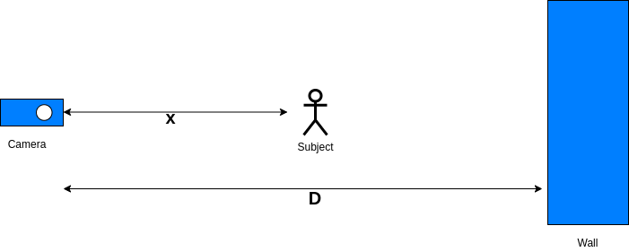
Fig: Distances involved in empirical assessment of Depth map quality

In the experiment, the value of D was set to 257 cm. The value was set from 257 cm to 60cm, taking uneven steps in x. The depth map appeared from 160cm and less. The depth maps of 160cm, 130cm, 100cm, 70 cm and 60 cm are viewed below.
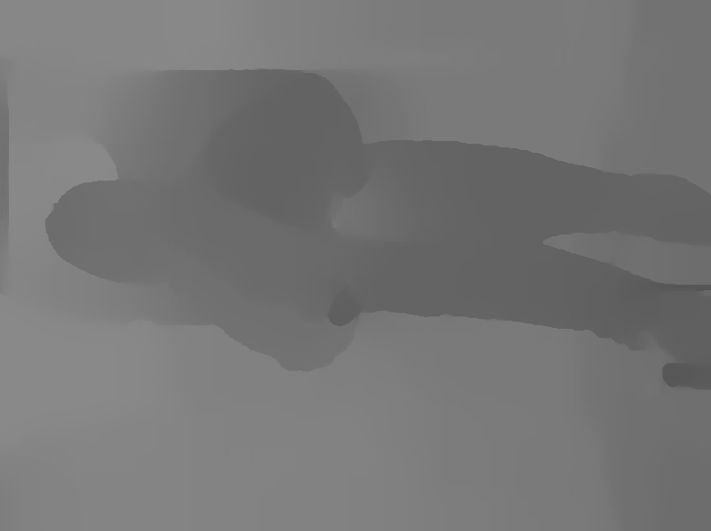

fig: Depth maps when value of x is 160cm,130cm,100cm,70cm and 60cm

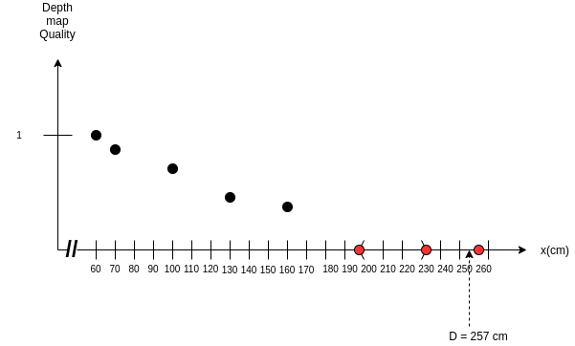
fig: Subjective Comparison of Depth Map quality

